Welcome to the fourth notebook of my series on using Machine Learning for trading, investing, and maximizing your chances of profiting in financial markets.
In this notebook, I would like to approach one of the most common strategies in trading, trend following.
Trend following is a trading strategy in which a trader aims to buy a financial security when prices are moving towards an upwards trend, and sell it whenever it starts moving towards a downwards trend. This specific strategy can be applied to any asset you would like to, such as stocks, futures, cryptocurrencies, forex pairs, among many others. It can also be applied to any timeframe, either for those looking to perform short trades on a 5-minutes timeframe, as well as on daily, weekly, or even monthly timeframe.
There are many different techniques to identify whether there is a trend or not. Among these techniques, one that is extremely popular, is the use of moving averages, which provides an intutive and visual guide into what direction prices are moving towards. Usually, a trader would select any moving average, such as a 5-period moving average, and buy when prices are above this moving average, and sell it when they are below it.
The goal of this notebook is to look at trend-following strategies through quantitative lenses, and observe how we can use Python, Data Science, and Machine Learning to develop an effective trend-following strategy for trading.

1 - Installing and Importing Libraries
In the following cells of code, we are going to install the Technical Analysis library, the yfinance library, and the quantstats library, all of which have been approached in my previous notebook, 🤑 Data Science for Financial Markets 📈💰.
# Importing Libraries
# Data Handlingimport pandas as pdimport numpy as np
# Data Visualizationimport matplotlib.pyplot as pltimport seaborn as snsimport plotly.express as pximport plotly.graph_objs as goimport plotly.subplots as spfrom plotly.offline import init_notebook_modeinit_notebook_mode(connected=True)
# Financial Data Analysisimport yfinance as yfimport taimport quantstats as qs
# Machine Learning from sklearn.metrics import confusion_matrix, roc_auc_score, auc, roc_curve
# Classification ML algorithmsfrom sklearn.linear_model import LogisticRegressionfrom xgboost import XGBClassifierfrom lightgbm import LGBMClassifierfrom catboost import CatBoostClassifierfrom sklearn.ensemble import AdaBoostClassifier, RandomForestClassifier, GradientBoostingClassifierfrom sklearn.neural_network import MLPClassifier
# Feature Selectionfrom sklearn.feature_selection import SelectKBest, f_classif
# Oversampling minority class for imbalanced datasetsfrom imblearn.over_sampling import SMOTE
# Feature Importancefrom sklearn.inspection import permutation_importance
# Hiding warnings import warningswarnings.filterwarnings("ignore")

2 - Data Preprocessing
We have already seen machine learning techniques being applied to stocks and crypto in previous works. This time, we are going to use data containing historic prices for Live Cattle Futures, negotiated at the Chicago Mercantile Exchange (CME), one of the largest derivatives exchanges in the world.
Similarly to the most previous experiment in this series, we are going to use the weekly interval period, in which each sample in the dataframe captures price and volume behaviours occured within a single week, from Monday to Friday.
# Loading Live Cattle weekly historic data lef = yf.download('LE=F', end = '2023-05-29',
interval = '1wk') # 1-week timeframelef
[*********************100%***********************] 1 of 1 completed
 | Open | High | Low | Close | Adj Close | Volume
Date
2002-03-04 | 74.675003 | 75.900002 | 74.025002 | 75.500000 | 75.500000 | 0
2002-03-11 | 75.800003 | 75.824997 | 73.000000 | 73.000000 | 73.000000 | 0
2002-03-18 | 72.074997 | 72.425003 | 69.775002 | 69.775002 | 69.775002 | 0
2002-03-25 | 69.699997 | 71.099998 | 69.699997 | 70.425003 | 70.425003 | 0
2002-04-01 | 71.625000 | 71.925003 | 68.675003 | 68.675003 | 68.675003 | 0
... | ... | ... | ... | ... | ... | ...
2023-04-24 | 173.300003 | 177.100006 | 173.300003 | 175.175003 | 175.175003 | 22408
2023-05-01 | 165.199997 | 165.774994 | 161.199997 | 161.925003 | 161.925003 | 159655
2023-05-08 | 161.925003 | 164.625000 | 161.774994 | 164.399994 | 164.399994 | 178222
2023-05-15 | 164.625000 | 166.225006 | 162.925003 | 165.725006 | 165.725006 | 81789
2023-05-22 | 165.649994 | 168.399994 | 163.649994 | 167.350006 | 167.350006 | 55489
1104 rows × 6 columns
By looking at the dataframe above, it's possible to see that the data avilable for Live Cattle Futures ranges from March 4ᵗʰ, 2002 up until the selected end date at May 29ᵗʰ, 2023.
Using Plotly, we can plot a Candlestick chart to see how prices for Live Cattle Futures have evolved throughout the past 20 years.

We can observe different price behaviors during the analyzed period. For instance, between 2003 and 2011, prices exhibited a sideways movement, ranging between USD 77.00 and USD 100.00 per contract, approximately. After a breakout in 2011, prices started an upward trend, reaching a peak of around USD 170.00 in November 2014.
From late 2014 to October 2016, prices experienced a downward trend, ultimately reaching the USD 95.00 mark, and remaining in a sideways range once again. Since March 2022, however, a new upward trend has emerged, which appears to be still ongoing as of May 2023.
In the next cell, we are going to split the dataframe into training and testing sets, segregating data from 2002 to 2012 for training, and from 2013 to 2023 for testing.
#Splitting data into training & testing setstrain = lef[lef.index.year <= 2012] test = lef[lef.index.year >= 2013]

3 - Feature Engineering
In this next step, I am going to define a function called new_features, which will perform numerous operations in the data we have downloaded to create new features to improve the predictive power of our machine learning algorithms.
The features I have developed here are extremely similar to those generated during feature engineering in the 🤖 Trading with Machine Learning: Weekly Returns notebook. If you wish to obtain further details regarding each of these features, I suggest you to click on the provided link to see the explanations on their functionality and implications.
Here, I will only delve deeper into the two most relevant features we are going to use to create our target variable. First, is the ema8 which is given by the following formula:
EMAt=α⋅Xt+(1−α)⋅EMAt−1
Where:
EMAt = is the EMA value at time t
Xt = Is the price at time t
α = Is the smoothing factor, which is calculated as 2n+1, where n is the number of periods of the EMA (in this case, n=8)
EMAt−1 = Is the EMA value at the previous time (t−1)
The exponential moving average, differently from the simple moving average, hands more weight to the most recent samples in a distribution. In this case, we can say that our 8-period exponential moving average gives much more emphasis to the most recent closing prices.
There is a wide discussion about which type of moving average is more effective. Overall, it can be said that the exponential moving average can capture changes and trends much faster than the simple moving average. However, it is also much less sensitive to noise and false breakouts, giving false signals more often than the simple moving average.
For this specific notebook, we are going to use the exponential moving average of the last 8 weeks, obtained by computing the mean of the Adj Close column. I encourage you to experiment with, not only different types of moving averages, such as the simple moving average and the weighted moving average, but also with different periods and different timeframes.
The other next feature I would like to approach is the close_to_ema8_ratio, which is given by the following formula:
Close to EMA8 Ratio = Adj Closeema8
This feature represents the relationship between the current closing price and the 8-period exponential moving average. When the value of this feature is below 1.0, it indicates that prices are being traded below the moving average, suggesting a possible downtrend. Conversely, when the value is above 1.0, prices are being traded above the moving average, indicating a potential uptrend. This feature also captures the distance between the price and the moving average. The further the value deviates from 1.0, the stronger the current trend may be.
Let's move forward to the feature engineering process and, further beyond, we will analyze both the two features mentioned above.
# Defining new featuresdef new_features(df):

# Features related to price behavior
df['high_low_ratio'] = df['High'] / df['Low']
df['open_adjclose_ratio'] = df['Adj Close'] / df['Open']
df['candle_to_wick_ratio'] = (df['Adj Close'] - df['Open']) / (df['High'] - df['Low'])
upper_wick_size = df['High'] - df[['Open', 'Adj Close']].max(axis = 1)
lower_wick_size = df[['Open', 'Adj Close']].min(axis = 1) - df['Low']
df['upper_to_lower_wick_ratio'] = upper_wick_size / lower_wick_size

# Laggings
df['lag1'] = df['Adj Close'].shift(1)
df['lag2'] = df['Adj Close'].shift(2)
df['lag3'] = df['Adj Close'].shift(3)
df['lag4'] = df['Adj Close'].shift(4)
df['lag5'] = df['Adj Close'].shift(5)

# Laggings ratio
df['close_to_lag1_ratio'] = df['Adj Close'] / df['lag1']
df['close_to_lag2_ratio'] = df['Adj Close'] / df['lag2']
df['close_to_lag3_ratio'] = df['Adj Close'] / df['lag3']
df['close_to_lag4_ratio'] = df['Adj Close'] / df['lag4']
df['close_to_lag5_ratio'] = df['Adj Close'] / df['lag5']

# Exponential Moving Average
df['ema8'] = ta.trend.ema_indicator(df['Adj Close'], window = 8)

# Volatility features
df['9_days_volatility'] = df['Adj Close'].pct_change().rolling(window = 9).std()
df['20_days_volatility'] = df['Adj Close'].pct_change().rolling(window = 20).std()
df['9_to_20_day_vol_ratio'] = df['9_days_volatility'] / df['20_days_volatility']

# Technical indicators
df['rsi'] = ta.momentum.RSIIndicator(df['Adj Close']).rsi()
df['rsi_overbought'] = (df['rsi'] >= 70).astype(int)
df['rsi_oversold'] = (df['rsi'] <= 30).astype(int)
df['cci'] = ta.trend.cci(df['High'], df['Low'], df['Adj Close'], window=10, constant=0.015)
df['obv'] = ta.volume.OnBalanceVolumeIndicator(close=df['Adj Close'], volume=df['Volume']).on_balance_volume()
df['obv_divergence_5_days'] = df['obv'].diff().rolling(10).sum() - df['Adj Close'].diff().rolling(5).sum()
df['obv_divergence_10_days'] = df['obv'].diff().rolling(20).sum() - df['Adj Close'].diff().rolling(10).sum()
df['ADX'] = ta.trend.ADXIndicator(df['High'], df['Low'], df['Adj Close'], window = 10).adx()
df['ADI'] = ta.volume.AccDistIndexIndicator(df['High'], df['Low'], df['Adj Close'], df['Volume']).acc_dist_index()

# Weekly returns
df['returns'] = np.round((df['Adj Close'].pct_change()) * 100, 2)

# Ratio between the closing price and the 8-period exponential moving average
df['close_to_ema8_ratio'] = df['Adj Close'] / df['ema8']

# Replacing infinite values by zeros
df = df.replace([np.inf, -np.inf], 0)

# Removing NaN values
df = df.dropna()
return df
# Applyig new_features function to both datasetstrain = new_features(train)test = new_features(test)
In the following output cell, you can see the results of applying the new_features function to the train dataset, and the new features added to the dataframe.
train # Displaying results

4 - Exploratory Data Analysis
Now that we have the 8-period exponential moving average in our dataset, we can plot both a Candlestick chart and the moving average to see how they interact with each other.
The result you see below is very similar to what technical analysts usually see on their chart software when analyzing securities using moving averages.

From 2002 to 2011, it is evident that Live Cattle Futures did not exhibit any kind of trend. Prices remained within a sideways range, and the moving average swinged around the closing price on a weekly basis.
By zooming in on the plot and focusing on the timeframe from January 2010 to December 2012, an emerging upward trend becomes visible. During this period, the price demonstrates the formation of ascending highs and lows, while the moving average tracks along with it.
Let's take a further look at the distribution of values in the close_to_ema8_ration variable throughout the training period.

With a median of around 1.006144, it can be said that, on average, the closing price have been slighlty above the 8-period exponential moving average during the training period. Overall, by analyzing the boxplot above, we can become biased towards the idea of buying Live Cattle Features, betting on an overall appreciation of our contracts.
However, I'd like to extract a little bit more information!
Below, I am going to segregate the close_to_ema8_ratio variable into eight different quantiles. This is going to separate the values within this variable into different ranges containing 12.5% of the total data each. Additionally to that, I will compute the mean of returns for each of these ranges. This is going to let us know how much the contracts appreciate or depreciate, on average, according to each range of ratios between the closing price and the 8-period moving average.
# Obtaining the mean of returns by range in the 'close_to_ema8_ratio' attributeoctiles = np.arange(0, 1.125, 0.125)octile_intervals = np.quantile(train['close_to_ema8_ratio'],
octiles)ranges = pd.cut(train['close_to_ema8_ratio'], octile_intervals)data = pd.DataFrame({'ranges': ranges,
'returns': train['returns']})mean_values = data.groupby('ranges')['returns'].mean()
crosstab = pd.crosstab(index = mean_values.index,
columns = 'mean_returns',
values = mean_values.values,
aggfunc = 'mean')crosstab
col_0 | mean_returns
row_0
(0.895, 0.971] | -2.441034
(0.971, 0.988] | -0.989828
(0.988, 0.998] | -0.432414
(0.998, 1.006] | 0.031034
(1.006, 1.013] | 0.101034
(1.013, 1.021] | 0.629828
(1.021, 1.033] | 1.202241
(1.033, 1.091] | 2.680517
By analyzing the table above, we are finally able to extract valuable insights for the creation of a target variable.
Overall, it is possible to see most ranges yield a positive mean of returns, once again indicating a more bullish sentiment to Live Cattle Futures.
In the code cell below, I am going to define a new function in which we are going to create the target variable according to the mean of returns observed in the ranges above. If the value in close_to_ema8_ratio is below the threshold of 0.998, that specific sample will be labeled as 0, while any value above that same threshold will be labeled as 1.
In addition to the labeling, we are also going to shift the target variable one sample backwards, as we want to capture the characteristics of the current week that culminated in a value of 1 or 0 in the following week.
# Creating target variabledef target(df):
df['target'] = np.where(df['close_to_ema8_ratio'] <= 0.998, 0, 1)
df['target'] = df['target'].shift(-1)
df = df.dropna()
return df
# Applying functiontrain = target(train)test = target(test)
You can see the results of the function above in the dataset below, by looking at the target column.
train # Displaying results
After adding the target variable to both our datasets, we can use a pie plot to see how the labels are distributed within the target variable in the training set.
This is going to be useful so we can have an overview on the amount of samples where close_to_ema8_ratio is within a range with a positive mean of returns.

Overall, 62.1% of samples belong to the 1 class. This reinforces the fact that the closing prices have traded mostly higher than the 8-period moving average during the training period.
As we now know the characteristics of the relationship between price and moving average, and have finally introduced a target variable to the datasets, we can start treating the data for modeling.
First and foremost, we are going to split both the training and testing sets into independent features (X) and target variable (y).
# Splitting data into Independent Features X and Target Variable yX_train = train.drop('target', axis = 1)y_train = train.target
X_test = test.drop('target', axis = 1)y_test = test.target
Considering that the analysis of the target variable through the pie plot displayed a huge class imbalance between the amount of samples belonging to the 0 label and to the1 label, I am going to use SMOTE to synthetically increase the amount of samples of the minority class. This is particularly useful to help diminish the effects of introducing bias to our models related to the majority class, and it helps our model to learn both the characteristics that would result in the target variable being labeled as each specific class.
# Applying oversampling using SMOTEsmote = SMOTE(random_state = 42)
X_train_oversampled, y_train_oversampled = smote.fit_resample(X_train,y_train)
After applying SMOTE to generate more samples of the minority class, we can visualize another pie plot and check the new class distribution within the training set.

We now ensure that both labels account for half of the total training data.

5 - Feature Selection
Just as the process of creating new features, selecting which of these features are the most relevant for the predictions we want to make is also an extremely important step.
Selecting the best features to act as predictors is crucial because it helps to eliminate redundancy in the data, which reduces the possibility of overfitting and improves the model's ability to generalize on unseen data.
In the following cell, we will use Sklearn's SelectKBest to perform some univariate statistical tests to identify the most relevant features according to its k score. We are also using a p-value lower than 5% as threshold for determining the statistical significance of the selected features.
# Selecting Features using SelectKBestk_best = SelectKBest(score_func = f_classif,
k = len(X_train.columns))
# Fitting and transforming dataX_train_best = k_best.fit_transform(X_train, y_train)X_test_best = k_best.transform(X_test)
feat_indices = k_best.get_support(indices = True)feat_names = X_train.columns[feat_indices]
p_values = k_best.pvalues_
selected_features = []
for feature, pvalue in zip(feat_names, p_values):
if pvalue < 0.05:
selected_features.append(feature)
print("Selected Features: \n")print(selected_features)
Selected Features:

['Open', 'High', 'Low', 'Close', 'Adj Close', 'high_low_ratio', 'open_adjclose_ratio', 'candle_to_wick_ratio', 'lag1', 'close_to_lag1_ratio', 'close_to_lag2_ratio', 'close_to_lag3_ratio', 'close_to_lag4_ratio', 'close_to_lag5_ratio', '9_days_volatility', '9_to_20_day_vol_ratio', 'rsi', 'rsi_overbought', 'cci', 'obv_divergence_5_days', 'obv_divergence_10_days', 'returns', 'close_to_ema8_ratio']
In the output cell above, we can see all features that were selected to act as predictors according to the conditions we have estabilished for the p-value. Following below, I will define new X datasets containing only the selected attributes above.
# Selecting only the best featuresX_train_best = X_train[selected_features]X_test_best = X_test[selected_features]

6 - Modeling
We finally reached the modeling part. I am going to define a list called classifier, which will consist of different classification algorithms.
Just as we have been doing in previous notebooks of this series, we are going to predict the probabilities of the y_test array containing either a 1 or a 0 in it.
The classifiers will then be evaluated using the Area Under the ROC Curve score, and we will select the one with the highest score.
# Creating list of classifiersclassifiers = [
LogisticRegression(random_state = 42),
XGBClassifier(random_state = 42),
LGBMClassifier(random_state = 42),
CatBoostClassifier(random_state = 42, verbose = False),
AdaBoostClassifier(random_state = 42),
RandomForestClassifier(random_state = 42),
GradientBoostingClassifier(random_state = 42),
MLPClassifier(random_state = 42)]
# Iterating over classifiers and computing AUC for clf in classifiers:
clf.fit(X_train_best, y_train)
preds = clf.predict_proba(X_test_best)[:,1]
auc_score = roc_auc_score(y_test, preds)
print(f'{type(clf).__name__}: AUC Score = {auc_score:.3f}')
LogisticRegression: AUC Score = 0.887
XGBClassifier: AUC Score = 0.841
LGBMClassifier: AUC Score = 0.857
CatBoostClassifier: AUC Score = 0.875
AdaBoostClassifier: AUC Score = 0.816
RandomForestClassifier: AUC Score = 0.877
GradientBoostingClassifier: AUC Score = 0.845
MLPClassifier: AUC Score = 0.618
The Logistic Regression model achieved the best AUC score at 0.887. In the following cell, I will build our final model and plot the Area Under the ROC Curve plot.

With an AUC score of 0.887, our model is performing much better than a random guess, which is represented on the plot above by the purple dashed line.
With such a good score, we might go on for the development of a trading strategy to test our performance against the Buy & Hold approach.
On the plot below, you can also see the most important features for our model's predictions. These importances were computing using Sklearn's permutation_importance.

7 - Creating a Trading Strategy
In the following code, you can see all the probabilities given as output by our predicting model.
y_pred # Displaying probabilities
Similarly to what I have done in previous notebooks, I will split the y_pred array into eight different ranges containing 12.5% of the total data each. I will then sum the total of 1s and 0s in the y_test array.
This is going to help us identify the ranges of probabilities that were more effective in predicting 1s and 0s in the real data. With this information at hands, we can develop a more robust trading strategy, where only specific ranges of probabilities given by the model will help us decide whether we buy or sell.
# Obtaining the sum of 0s and 1s by probability rangeoctiles = np.arange(0, 1.125, 0.125)intervals = np.quantile(y_pred, octiles)classes = pd.cut(y_pred, intervals)table = pd.crosstab(classes, y_test)table
target | 0.0 | 1.0
row_0
(0.0198, 0.209] | 61 | 4
(0.209, 0.351] | 46 | 19
(0.351, 0.607] | 40 | 25
(0.607, 0.766] | 20 | 45
(0.766, 0.853] | 11 | 54
(0.853, 0.898] | 7 | 58
(0.898, 0.933] | 4 | 61
(0.933, 0.988] | 2 | 63
It is evident that probabilities ranging from 0.0198 to 0.607 have been more effective in predicting the occurrence of 0s in the real data, while probabilities higher than 0.607 have shown greater effectiveness in predicting the occurrence of 1s in y_test.
We will then utilize the value of 0.607 as threshold. In the following cell, I will generate a sign array that represents the model's output based on the probability values. Any probability equal to or below 0.607 will result in an output of -1, indicating an opportunity for short-selling. On the other hand, probabilities higher than 0.607 will result in an output of 1, indicating a buying opportunity.
With these parameters, our trading strategy involves staying in the market 100% of times, with the aim of achieving profits through both buying and short-selling Live Cattle Futures.
# Creating signsign = np.where((y_pred <= 0.607), -1, 1)sign # Visualizing results
I will now add the signals above to the X_test dataframe and create a new column called position, which will indicate whether we were betting on the appreciation or depreciation of the futures contracts in each specific week according to the signals in sign.
The model_returns column will be the result of multiplying position by returns, and will indicate the percentage values of either profits or losses in each specific week.
X_test['sign'] = sign # Model's predictions for next weekX_test['position'] = X_test['sign'].shift(1) # Current positionX_test['model_returns'] = X_test['position'] * X_test['returns'] # Obtaining return according to model's predictionsX_test # Displaying results on the dataframe
 | Open | High | Low | Close | Adj Close | Volume | high_low_ratio | open_adjclose_ratio | candle_to_wick_ratio | upper_to_lower_wick_ratio | ... | obv | obv_divergence_5_days | obv_divergence_10_days | ADX | ADI | returns | close_to_ema8_ratio | sign | position | model_returns
Date
2013-05-27 | 120.775002 | 121.750000 | 120.175003 | 121.300003 | 121.300003 | 40610 | 1.013106 | 1.004347 | 0.333335 | 0.749997 | ... | -388473 | -292254.450005 | -549248.100006 | 28.790132 | -789078.630910 | 0.60 | 0.990228 | -1 | NaN | NaN
2013-06-03 | 121.275002 | 121.599998 | 119.949997 | 120.125000 | 120.125000 | 43712 | 1.013756 | 0.990517 | -0.696970 | 1.857093 | ... | -432185 | -400940.300003 | -432473.225006 | 30.181116 | -823518.235366 | -0.97 | 0.984874 | -1 | -1.0 | 0.97
2013-06-10 | 120.000000 | 120.775002 | 119.000000 | 119.000000 | 119.000000 | 24292 | 1.014916 | 0.991667 | -0.563380 | 0.000000 | ... | -456477 | -364824.550003 | -526252.974998 | 31.890209 | -847810.235366 | -0.94 | 0.980959 | -1 | -1.0 | 0.94
2013-06-17 | 119.125000 | 121.625000 | 118.775002 | 121.250000 | 121.250000 | 16472 | 1.023995 | 1.017838 | 0.745614 | 1.071433 | ... | -440005 | -309391.849998 | -567392.400002 | 32.346011 | -835672.974529 | 1.89 | 0.999616 | -1 | -1.0 | -1.89
2013-06-24 | 121.175003 | 121.875000 | 118.150002 | 118.150002 | 118.150002 | 34154 | 1.031528 | 0.975036 | -0.812081 | 0.000000 | ... | -474159 | -360127.575005 | -552893.800003 | 33.116217 | -869826.974529 | -2.56 | 0.979706 | -1 | -1.0 | 2.56
... | ... | ... | ... | ... | ... | ... | ... | ... | ... | ... | ... | ... | ... | ... | ... | ... | ... | ... | ... | ... | ...
2023-04-17 | 174.850006 | 177.000000 | 172.699997 | 173.975006 | 173.975006 | 8916 | 1.024899 | 0.994996 | -0.203488 | 1.686258 | ... | -190914 | -49924.650009 | 329827.224991 | 51.644118 | 235038.459657 | -0.44 | 1.030170 | 1 | 1.0 | -0.44
2023-04-24 | 173.300003 | 177.100006 | 173.300003 | 175.175003 | 175.175003 | 22408 | 1.021927 | 1.010819 | 0.493421 | 0.000000 | ... | -168506 | -39633.175003 | 332857.399994 | 53.464972 | 234743.599793 | 0.69 | 1.028754 | 1 | 1.0 | 0.69
2023-05-01 | 165.199997 | 165.774994 | 161.199997 | 161.925003 | 161.925003 | 159655 | 1.028381 | 0.980176 | -0.715846 | 0.793093 | ... | -328161 | -205507.574997 | 164825.274994 | 48.238964 | 125690.097790 | -7.56 | 0.961422 | -1 | 1.0 | -7.56
2023-05-08 | 161.925003 | 164.625000 | 161.774994 | 164.399994 | 164.399994 | 178222 | 1.017617 | 1.015285 | 0.868416 | 1.499949 | ... | -149939 | -131325.324997 | 338418.025009 | 43.535557 | 275771.078912 | 1.53 | 0.981325 | -1 | -1.0 | -1.53
2023-05-15 | 164.625000 | 166.225006 | 162.925003 | 165.725006 | 165.725006 | 81789 | 1.020255 | 1.006682 | 0.333335 | 0.294118 | ... | -68150 | 106569.024994 | 442327.549988 | 39.708505 | 332775.556378 | 0.81 | 0.991607 | -1 | -1.0 | -0.81
521 rows × 38 columns
In the next code cell, I will obtain the decimal values for both the model_returns and the overall returns of Live Cattle Futures. These decimal values will be then given as input for Quantstats to generate a performance report.
# Obtaining decimal valuesmodel = X_test['model_returns'] / 100buy_hold = X_test['returns'] / 100
# Generating performance reportqs.reports.full(model,
benchmark = buy_hold)

Performance Metrics
Strategy Benchmark
------------------------- ---------- -----------
Start Period 2013-05-27 2013-05-27
End Period 2023-05-15 2023-05-15
Risk-Free Rate 0.0% 0.0%
Time in Market 100.0% 100.0%

Cumulative Return 62.16% 37.56%
CAGR﹪ 4.97% 3.25%

Sharpe 0.75 0.57
Prob. Sharpe Ratio 85.94% 79.13%
Smart Sharpe 0.71 0.55
Sortino 1.1 0.76
Smart Sortino 1.05 0.73
Sortino/√2 0.78 0.54
Smart Sortino/√2 0.74 0.51
Omega 1.14 1.14

Max Drawdown -39.84% -50.27%
Longest DD Days 1043 3052
Volatility (ann.) 44.19% 44.21%
R^2 0.0 0.0
Information Ratio 0.01 0.01
Calmar 0.12 0.06
Skew 0.05 -0.85
Kurtosis 3.48 3.6

Expected Daily % 0.09% 0.06%
Expected Monthly % 0.4% 0.26%
Expected Yearly % 4.49% 2.94%
Kelly Criterion 5.62% 7.35%
Risk of Ruin 0.0% 0.0%
Daily Value-at-Risk -4.45% -4.48%
Expected Shortfall (cVaR) -4.45% -4.48%

Max Consecutive Wins 7 8
Max Consecutive Losses 7 9
Gain/Pain Ratio 0.14 0.11
Gain/Pain (1M) 0.3 0.23

Payoff Ratio 0.98 0.98
Profit Factor 1.14 1.11
Common Sense Ratio 1.33 0.89
CPC Index 0.6 0.59
Tail Ratio 1.16 0.81
Outlier Win Ratio 3.8 3.91
Outlier Loss Ratio 3.96 3.83

MTD -9.71% -5.39%
3M -3.31% 1.33%
6M 3.32% 8.27%
YTD 2.16% 7.05%
1Y 9.02% 25.5%
3Y (ann.) 5.46% 20.59%
5Y (ann.) 13.15% 9.03%
10Y (ann.) 4.97% 3.25%
All-time (ann.) 4.97% 3.25%

Best Day 12.51% 10.34%
Worst Day -14.79% -14.79%
Best Month 23.77% 16.68%
Worst Month -22.43% -21.63%
Best Year 32.91% 23.02%
Worst Year -22.92% -18.02%

Avg. Drawdown -7.9% -5.11%
Avg. Drawdown Days 169 189
Recovery Factor 1.56 0.75
Ulcer Index 0.17 0.27
Serenity Index 0.34 0.09

Avg. Up Month 3.79% 4.1%
Avg. Down Month -4.82% -3.23%
Win Days % 53.19% 54.05%
Win Month % 58.33% 57.02%
Win Quarter % 63.41% 56.1%
Win Year % 63.64% 63.64%

Beta -0.07 -
Alpha 0.35 -
Correlation -6.62% -
Treynor Ratio -939.92% -
None

5 Worst Drawdowns
 | Start | Valley | End | Days | Max Drawdown | 99% Max Drawdown
1 | 2017-05-01 | 2018-09-03 | 2020-03-09 | 1043 | -39.838492 | -38.544205
2 | 2014-05-26 | 2016-02-08 | 2017-02-20 | 1001 | -30.979316 | -29.849091
3 | 2022-02-21 | 2022-07-11 | 2023-04-10 | 413 | -21.498145 | -21.298634
4 | 2020-04-27 | 2020-06-01 | 2021-11-01 | 553 | -15.920119 | -15.199703
5 | 2023-05-01 | 2023-05-15 | 2023-05-15 | 14 | -9.711640 | -8.974332

Strategy Visualization
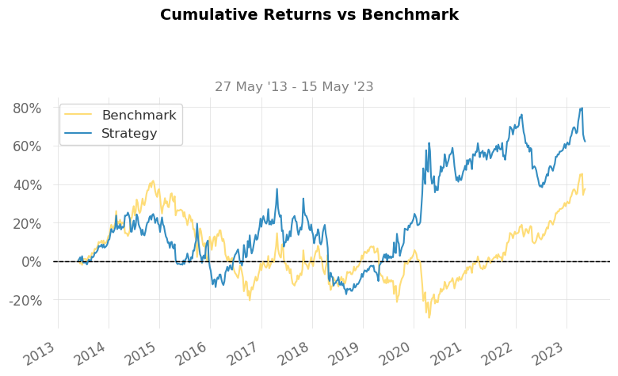
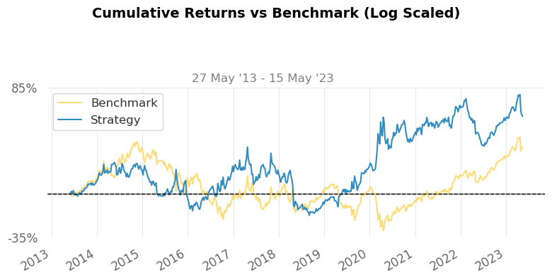
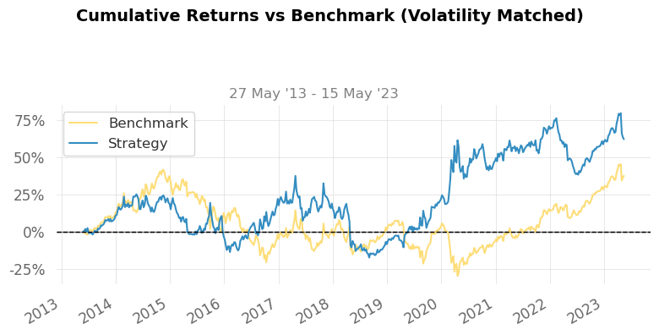
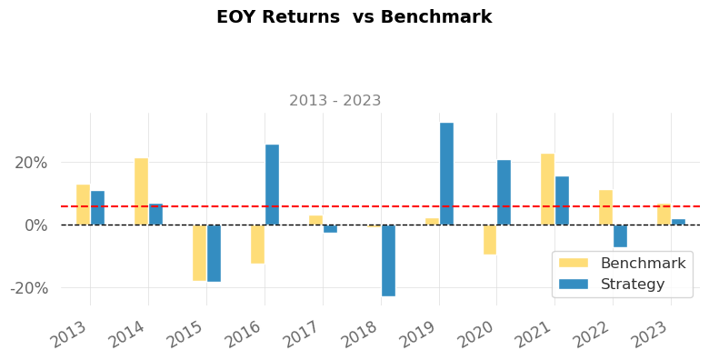
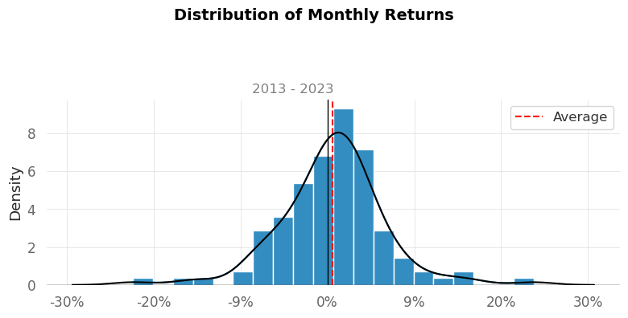
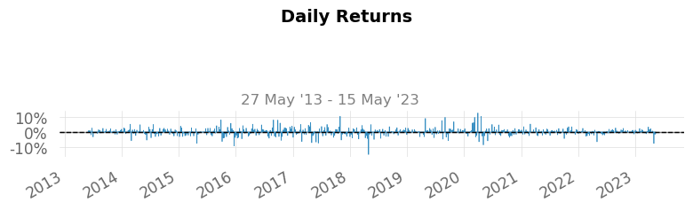
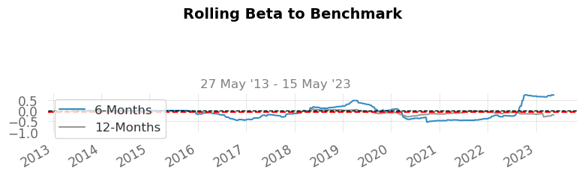
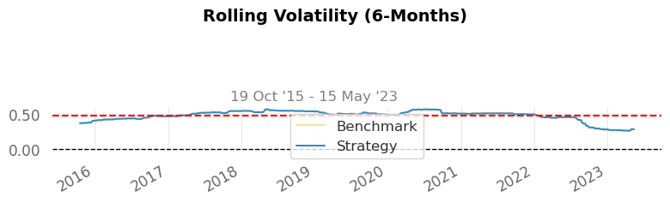
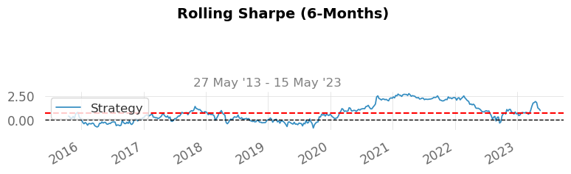
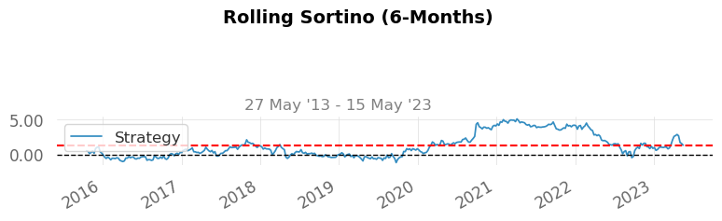
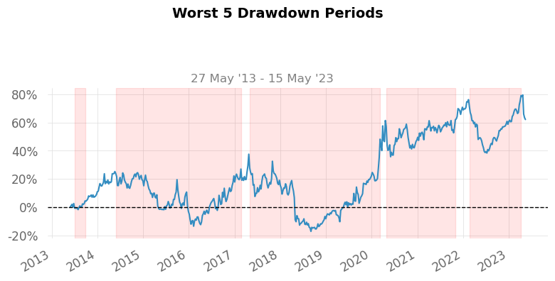
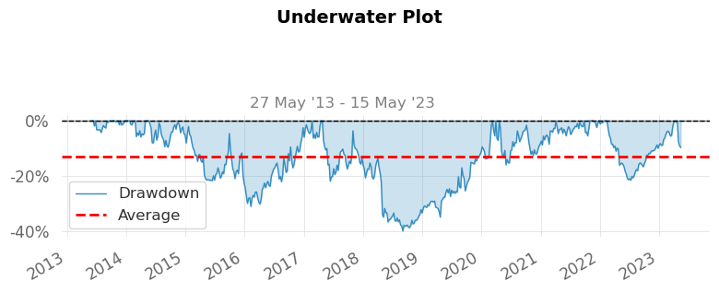
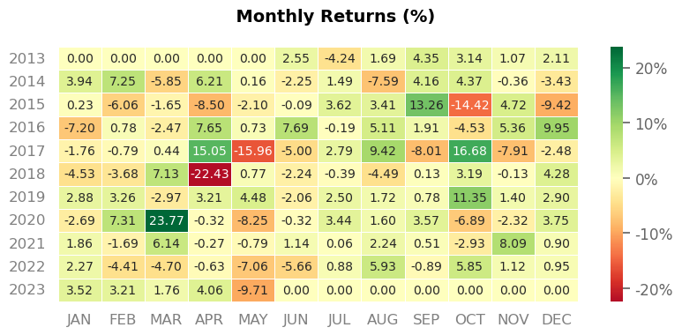
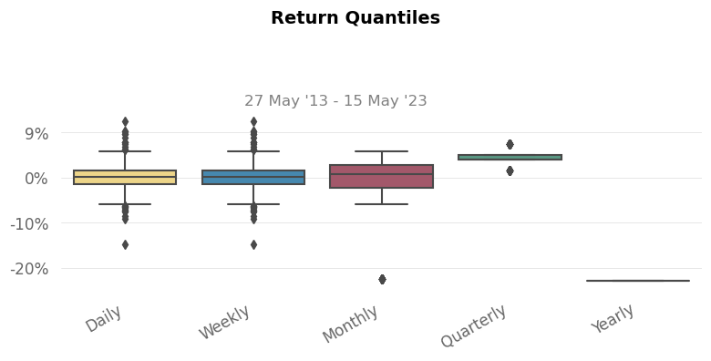
When comparing the cumulative returns over the past 10 years, our strategy outperformed the Buy & Hold approach with a total return of 62.16%, while the latter returned only 37.56%.
Beyong that, our strategy also exhibited higher Sharpe and Sortino ratios, 0.75 and 1.1 respectively. These values indicate a more favorable risk-return relationship compared to the Buy & Hold approach.
Although both strategies display a high annual volatility, with our model at 44.19% and the Buy & Hold at 44.21%, it is worth noting that our strategy achieved a lower maximum drawdown of -39.84%. This value is still, however, somewhat high, and improvements could be made in this regard.
Additionally, our strategy demonstrated superior performance in terms of the Recovery Factor, Ulcer Index, and Serenity Index, surpassing those of the Buy & Hold. These results suggest that following our strategy provides a more stable investment experience compared to simply holding the asset.
It is, though, essential to acknowledge that there is much room for improvement, specially in relation to periods of drawdown. The Worst 5 Drawdown Periods plot in the report clearly indicates significant drawdowns periods experienced by our model during the testing period. In future experiments, it would be beneficial to focus on reducing the duration and intensity of drawdowns.

8- Conclusion
In this notebook, we have explored the relationship between price and moving average to identify potential trading opportunities in the Live Cattle Futures contract on the CME by applying a trend-following strategy.
Even though the strategy developed in this notebook outperformed the Buy & Hold approach in terms of both performance and risk, there are still numerous improvements to be made that could enhance risk management and potentially boost returns. A possibility of improvement would be exploring different periods for the moving average, as well as considering alternative types of moving averages, such as simple moving averages or weighted moving averages.
It is important to note that trend-following strategies can vary significantly. While we focused on the relationship between price and a single moving average in this notebook, you can also explore the interaction between different moving averages, where one represents a shorter period and the other represents a longer period of time.
It is also noteworthy to recognize that there is no one-size-fits-all strategy. By examining the Candlestick chart at the beginning of this notebook, we may observe that the future contracts exhibited a sideways movement for many years. This observation suggests that a trend-following strategy based on moving averages might not be the most effective approach for this particular security. For this reason, I encourage you to explore not only different methods for identifying and following trends but also to apply the concepts seen in this notebook to other securities and time intervals.
Please feel free to share your comments, suggestions, and insights! Your feedback is of great importance to assist in improving these notebooks.

